1. Create a no-argument constructor for ListNode class that will set the lastName property to  “Dela Cruz”, firstName property to “Juan”, and next and previous properties to null. Assume  that the variables used as properties are declared private.

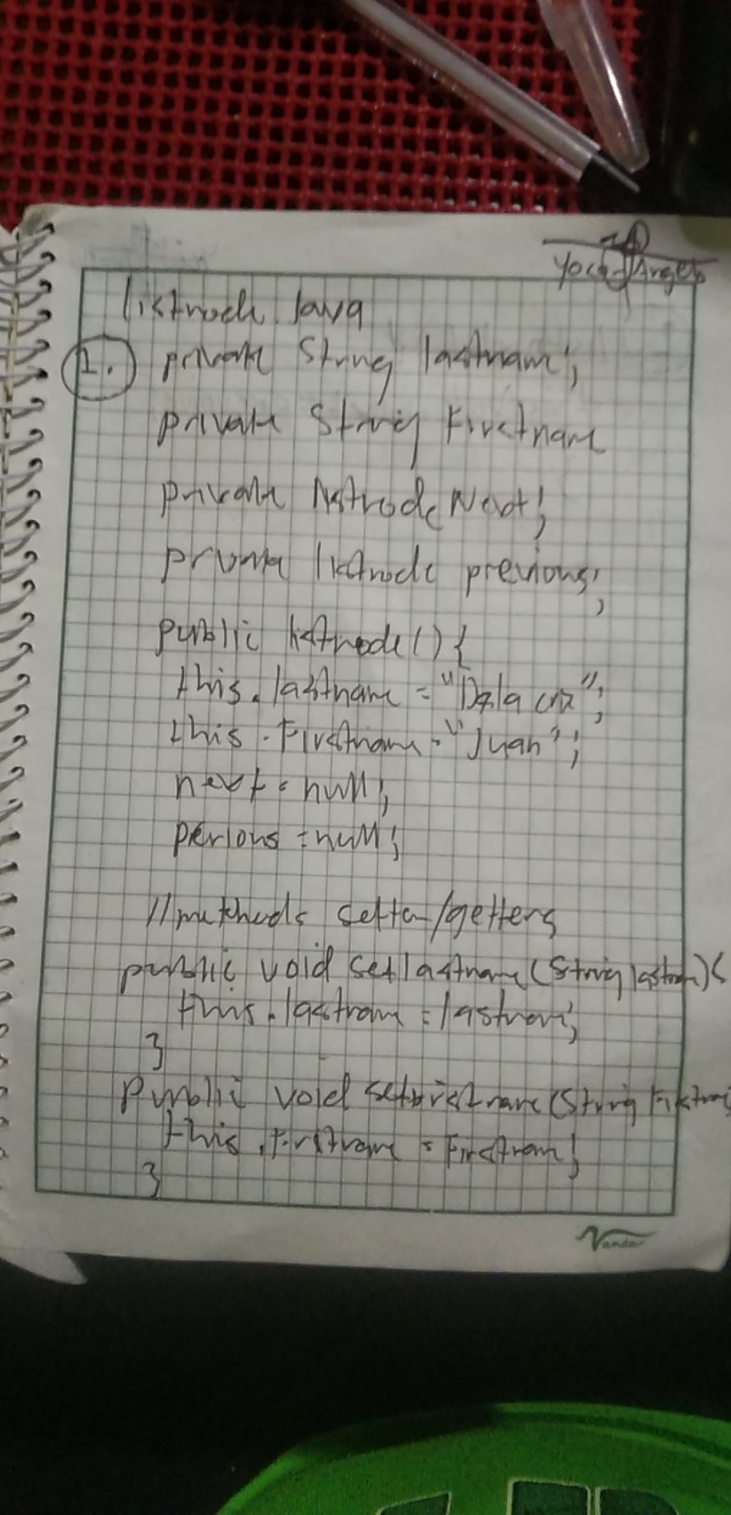

2 Using the class information in question 1 as reference, change the memory address of thisNode  (an object of ListNode class) to the memory address referenced by its previous property

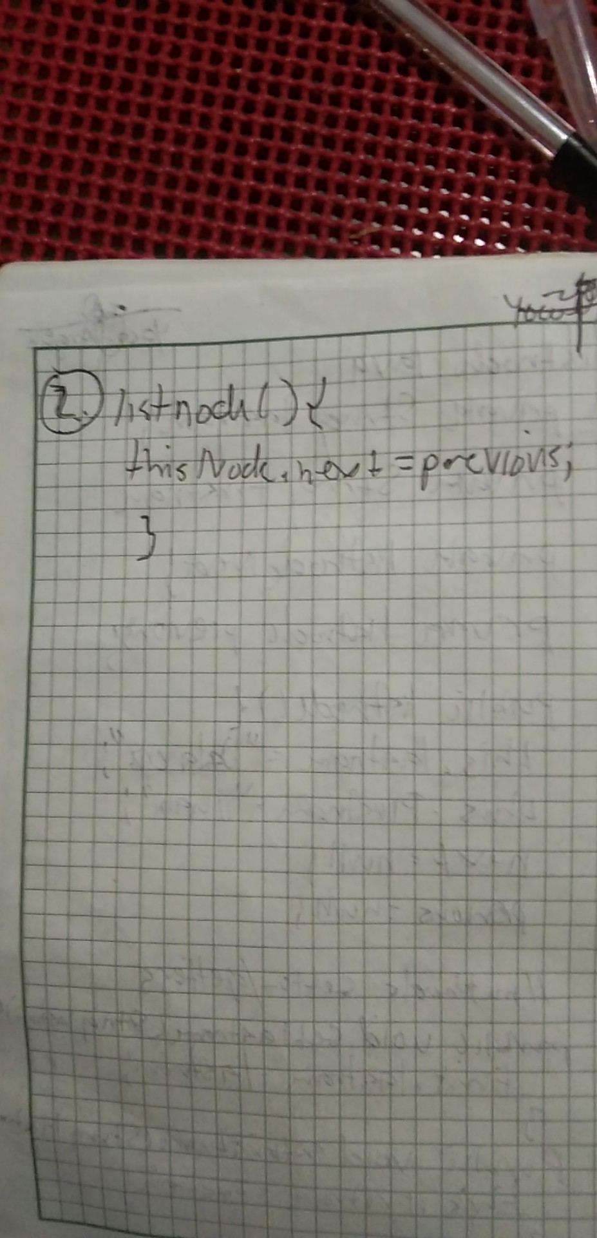

3. Using the class information in question 1 as reference, create a while loop to traverse the linked  list and display the names vertically using the format “Last Name, First Name”. Use thisNode  (an object of ListNode class) to traverse the linked list. Assume head (also an object of  ListNode class) holds a reference to the first node of the linked list. Sample output is given  below:

Kanzaki, Sheero

Dela Cruz, Juan

Pecson, Miguel

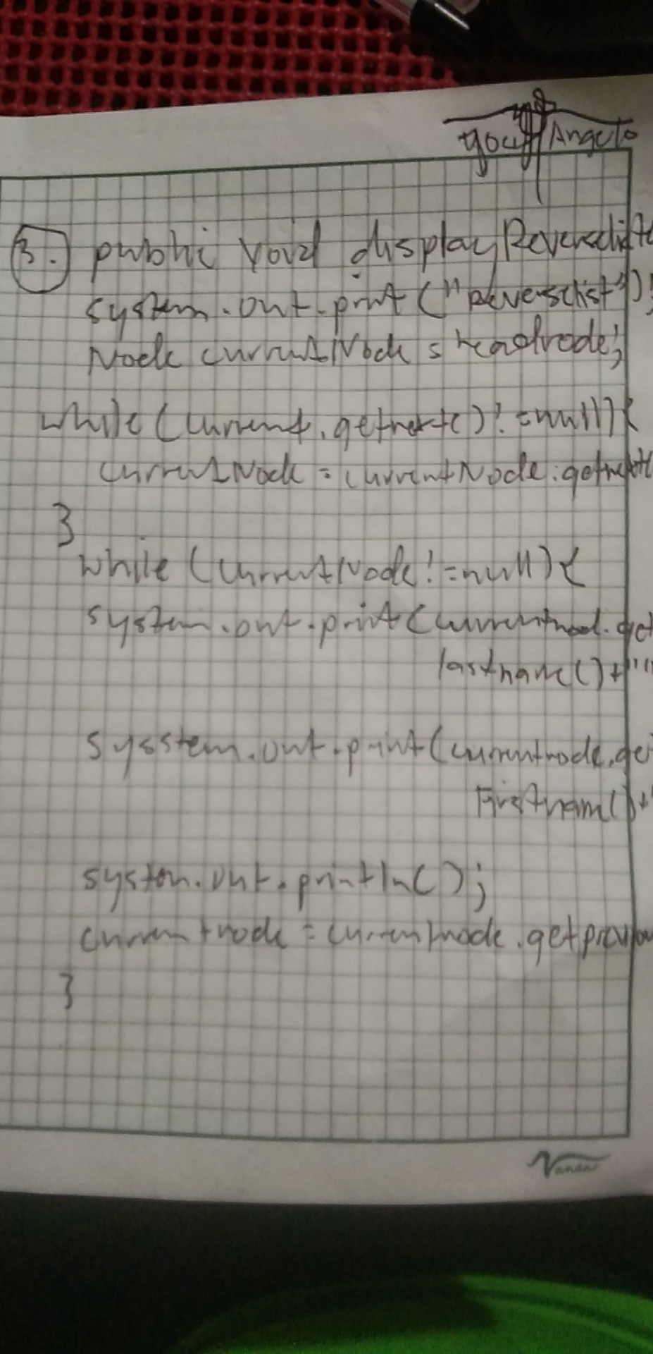

4. Change the memory address of thisNode (an object of ListNode class) to the memory address  of the second node in the linked list. Assume head (also an object of ListNode class) holds a  reference to the first node of the linked list.

5. Remove the second node from the linked list by setting its reference to null. Assume head (an  object of ListNode class) holds a reference to the first node of the linked list.

4 and 5 Screenshot

